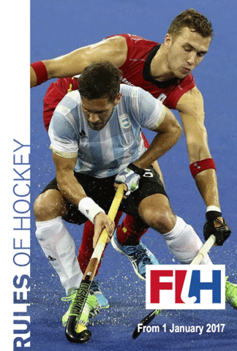
Rules

FIH rules 2017 – download rule book at Hockey Australia Website
Resource provided by Ballina Hockey Association

Quick guide to field hockey rules
- Much of this information was adapted from the Hockey Australia web site.
- Playing System Positions – traditional 5-3-2-1 or 3,3,3,1 set up.

Duration of the game
2 x 35 minutes halves. 5 minutes at half-time plus time-outs for penalty-strokes and injuries. Within the Tweed competition, the U11 and U13 25 minute halves, U16 teams play 30 minute halves. U9s and U7s play a modified format of the game.

How many players in a team
The game is played between 2 teams – 11 players for each team on the field and up to 5 substitutes on the sideline. Not more than 11 players from each team shall be on the field at the same time. Substitutions can be made at any time, except during a penalty corner and must be made at the half-way line. Any number of substitutions can be made. Each team will usually have a goalkeeper on the field, but in some situations, the coach may decide to play with 11 field players.

Players
Each team will normally divide its players into 3 groups. These are known as the defence, the midfield, and the attack. Obviously, all players attack and defend, but you would soon get tired if you tried to do everything, and that is why there may be specialist positions for players.

Umpires
There are 2 umpires in each game of hockey. Together they are responsible for all the field. The 2 umpires work together, to form the 3rd team on the field. They are responsible for penalising offences against the rules appropriately, and maintaining safety and control. The umpires need to co-operate and communicate with skill and judgement. Umpires need to stay calm and concentrate at all times.

Umpiring can be just as much fun as playing. The third member of the umpiring and officials team is the tech bench official. They look after the time keeping, scores and match cards. If you are not umpiring on a synthetic hockey pitch with an electronic score board, you need a watch to keep time and a pen plus small pad to count the goals scored.

Whistling
An umpire needs to blow the whistle firmly and loudly so players can hear it.

Signalling
An umpire needs to signal clearly and positively so players can see what decision has been made.

Starting the Game
A centre pass is used to start the game. It is also used to re-start the game after a goal has been scored and after half time. The teams change ends at half time. If the ‘blue team’ starts the game with the centre pass, then the ‘red team’ shall start it after half time.

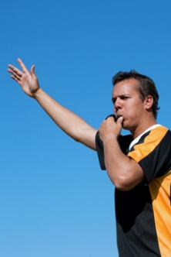

Scoring a goal
A goal is scored when the whole ball has completely crossed the whole goal line. It must have been touched by an attacker’s stick inside the shooting circle. When a goal is scored, the umpire shall blow the whistle and turn and point both arms towards the centre of the field.

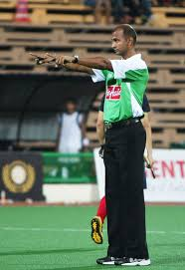

Penalties
These are awarded following unintentional or intentional offence. The umpire is responsible for recognising the offence and then applying the appropriate technical or personal penalty.

If the offence was unintentional and in the general field of play, the umpire shall usually award a free-hit. At times, it may give more ‘advantage’ to the team fouled against to allow play to continue

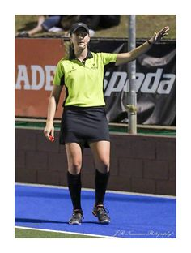

An unintentional foul in the circle usually results in a penalty corner, but if it prevents a probable goal from being scored, a penalty stroke should be awarded.
If the offence was intentional, and in the general field of play, the umpire may first warn or issue a personal penalty (card) to the offending player/s and then award the free hit. If the intentional foul was made on an attacker within the attacking 23m area, a short corner should be awarded and the player given the appropriate personal penalty (card).

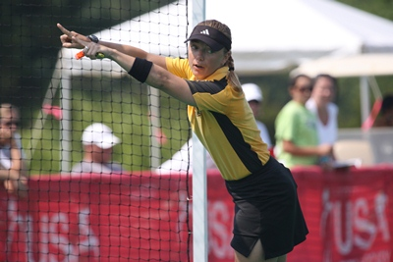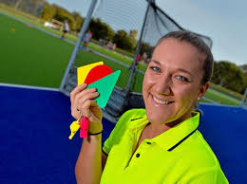

For an intentional offence by a defender in the circle against an attacker who has the ball or an opportunity to play the ball, the umpire shall award a penalty stroke.

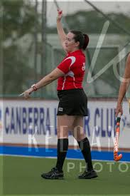

It is important to understand that an umpire must be able to recognise the difference between intentional and unintentional offences

Offences – what you cannot do!

Back-sticks
You cannot play the ball with the back of the stick

Feet
You cannot deliberately stop or play at the ball with your body, leg, foot, arm, hand, etc.

Obstruction
You cannot stand still and shield the ball when an opponent is attempting to tackle you. You must either pass the ball or move away in any direction (except bodily into the opponent).

Rough play
You cannot push or trip or interfere with an opponent in any way.

Stick-tackling
You cannot hit, hold or hook an opponent’s stick with your stick.

Dangerous play
You cannot play the ball in a dangerous manner towards another player or use your stick in a dangerous way. You cannot lift your stick over the head of another play to try and ‘force’ obstruction. In most grades, you cannot play the ball above your shoulder, unless you are in the goals and defending a shot on goal.

When shooting for goal, if you lift the ball above knee height within 5m of the defenders, and they are hit or must take legitimate evasive action, it is a free hit to the defence.

Special rules for the goal keeper
Goalkeepers are allowed to do each of the following (but only in their own circle).

- Stop the ball with a hand or any part of the body.
- Kick the ball as long as it’s not dangerous to other players.
- Stop the ball with the stick held above shoulder height, as long as it’s not dangerous to other players.
- Play the ball outside the circle with the stick only.

Ball out of play

Over the side-line
A hit-in shall be awarded. The ball shall be played along the ground, from the spot where it went out, and all opponents shall be at least 5 metres from the ball.

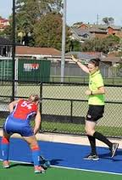

Over the back-line (by an attacker)
A ’16’ shall be awarded to the defenders. The ball shall be played along the ground on a spot opposite where the ball crossed the back-line up to 14.63m (16 yards) into the pitch (level with the top of the circle). All opponents shall be at least 5 metres from the ball.
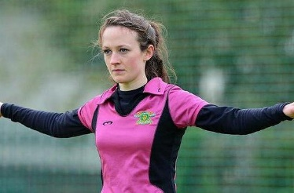

Over the back-line (by a defender)
If the defender accidentally hits or deflects the ball over their own back-line from anywhere on the field, a long corner shall be awarded. The ball shall be played along the ground, on the s23m line, opposite where the ball crossed the back-line. All attackers and defenders shall be at least 5 metres away and the ball must travel 5 metres, or be touched by another player, before entering the circle. Note: This applies only when the ball has unintentionally been put over the back-line by a defender.

When it has been intentionally put over the back-line by a defender, from anywhere on the field, the umpire shall award a penalty corner. A goalkeeper may intentionally kick or deflect a ball hit by an attacker over the back-line without a penalty corner being awarded. However, if a goalkeeper intentionally kicks a ball over the back-line, or uses their stick or glove to hit or push a ball over the back-line in a separate movement (rather than deflecting a ball hit by a player from either team), a penalty corner should be awarded against them.

Penalty Corner
A penalty corner is awarded when a defender unintentionally commits an offence in the circle or intentionally hits the ball over the back-line from anywhere in the field. Remember also that a penalty corner can be awarded for any intentional offence by a defender in the 22.90m (23 metre) area.

Umpires – important things for you to know about penalty corners
The ball shall be played from the back-line 9.10m (10 yards) from the goal post. No more than 5 defenders are to stand behind the back-line and must be at least 5 metres away from the taker. All of their teammates must be the other side of the halfway line.

All attackers must be outside the circle until the ball is played. The ball must be stopped outside of the circle BEFORE a shot at goal is made unless it has already gone beyond 5 metres of the circle’s edge. If the first shot is a hit, it cannot cross the goal line at above 460mm (18 inches) unless it is deflected on the way. A push or flick may be higher if it’s not dangerous to other players.

Until the ball has travelled outside the circle, no goal can be scored.
If a defender is wearing a face mask, they are not permitted to play outside the circle until they have removed their face mask and it is safely outside the field of play. Common sense should prevail and umpires should allow a defender to complete their defensive play for a few steps outside the circle if it is obvious they are not intending to play more than 5m from the circle (indicated by the dotted line).

Penalty stroke
A penalty stroke is awarded for an unintentional offence by a defender in the circle that prevents a probable goal from being scored, or an intentional offence by a defender in the circle against an attacker who has the ball or an opportunity to play the ball.

How does an umpire signal a penalty stroke?
After blowing the whistle, the umpire points one arm to the penalty spot and the other directly upwards.

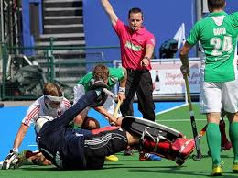

Umpires – Important things for you to know
In most games, when you award a penalty stroke you must stop the clock. In the Tweed competition, we do not usually stop the clock for penalty strokes in round matches.

To set up for the stroke, you place the ball on the Penalty Stroke Spot (6.40m (7 yards) from the centre of the goal line. The other umpire comes to the left side of the goal to assist. Apart from the penalty stroke taker, the goalkeeper and the other umpire, all players must be moved to the other side of the nearest 22.90m (23 metre) line. The goalkeeper must stand with heels on the goal line and cannot move until the stroke is taken. The stroke-taker stands behind the ball and cannot play the ball until you blow the whistle. The stroke-taker must start within playing distance of the ball – they cannot take a run up. The ball must completely cross the goal line before you can award the goal. You take a position so that you can see the striker and goalkeeper in your vision at the same time.

Your colleague (the other umpire) shall stand on the back-line near the penalty corner spot to check that the whole ball completely crosses the whole goal line. If the goalkeeper makes a save, as soon as the ball has been prevented from crossing the goal line, the penalty stroke is over. The attacker cannot approach the ball again.
If a goal has been scored then you re-start the game with a centre pass to the team who have just conceded the goal. If a goal has not been scored, you re-start the game with a 14.63m (16 yards) free hit to the defence.

Get accredited
And don’t forget, if you want more information about the Rules of Hockey, and how to become accredited, contact the Umpire Convenor in your local association, or check out the Umpiring resources on Hockey Australia Website

www.hockey.org.au
Got to Officiating and you will see all hockey umpiring resources.

This information has been modified by Robyn Pascoe from Hockey Rules Okay written by Jane Nockolds and Natalie D Beckerman. Information on the latest rules has been incorporated by Helen Rankin Jarvie.

